ACC U-19 Elite Cup 2007

P L A Y I N G C O N D I T I O N S

- TITLE

The Tournament shall be known as ACC U-19 ELITE CUP 2007 and organized by Malaysian Cricket Association (MCA) on behalf of Asian Cricket Council.

- QUALIFICATION

- At least 9 of the playing eleven must qualify under the category of ‘Nationals’ and the balance 2 players must qualify under ‘Deemed Nationals’ category as per the Qualification Rules for International Cricket Council matches, series and competitions effective 1st October 2002. The cut off date for the purpose of this rule is 15th August 2007.

- All players registered must be born on or after 1st September 1987.

- Any participating country unable to meet the qualification requirement will not be allowed to play in the tournament.

- TEAM COMPOSITION

Each team will be limited to 14 players 1 Manager, 1 Coach, and 1 Physio/Trainer (Total 17). Each participating Country will have to register their team of 14 players and 4 reserves along with the names of Manager, Coach & Physio/Trainer on the registration form no later than 1st August 2007 by e.mail or fax. The original hard copy duly signed by the President/Chairman of the Cricket Association to be handed over to the Organising Committee upon arrival. The reserve players may only replace a player from the original squad of 14 players prior to the commencement of the tournament on medical grounds or in exceptional circumstances. An approval from the ACC is required to replace a player from the original squad.

- PARTICIPATING TEAMS

Group ‘A’ Group ‘B’ ’

NEPAL MALAYSIA
THAILAND HONG KONG
OMAN QATAR
U.A.E. KUWAIT
SINGAPORE AFGHANISTAN

- MATCH VENUES

Selangor Turf Club (STC) / KINRARA OVAL / BAYUEMAS OVAL / CLUB AMAN / Royal Selangor Club (R.S.C.)

- TOURNAMENT FORMAT AND SCHEDULE

Each team shall play one match against the other from their group and the top two teams from each group
shall play a cross-over Semi-final. The winners of the two semi-finals shall play the grand Final for the 1st and 2nd position whereas the losing semi-finalists shall play for the 3rd and 4th place. Likewise there shall be play-off matches where A3 shall play B3 for the 5th and 6th placing, A4 shall play B4 for the 7th and 8th placing and A5 shall play B5 for the 9th and 10th placing.

The schedules of the matches is as follows :
Day Date Match between Venue

Mon 20 August 2007 Nepal vs Singapore S.T.C.
- do - Malaysia vs Afghanistan Kinrara Oval
- do - Thailand vs Oman Bayuemas Oval
- do - Hong Kong vs Qatar Club Aman

Tue 21 August 2007 Thailand vs UAE S.T.C.
- do - Oman vs Singapore Kinrara Oval
- do - Hong Kong vs Kuwait Bayuemas Oval
- do - Qatar vs Afghanistan Club Aman

Wed 22 August 2007 Nepal vs UAE Kinrara Oval
- do - Malaysia vs Kuwait Club Aman

Thu 23 August 2007 Malaysia vs Hong Kong S.T.C.
- do - Nepal vs Thailand Bayuemas Oval

Fri 24 August 2007 Oman vs UAE S.T.C.
- do - Hong Kong vs Afghanistan Kinrara Oval
- do - Qatar vs Kuwait Bayuemas Oval
- do - Thailand vs Singapore Club Aman

Sat 25 August 2007 Malaysia vs Qatar Kinrara Oval
- do - UAE vs Singapore Bayuemas Oval
- do - Nepal vs Oman Club Aman
- do - Kuwait vs Afghanistan R.S.C.

Sun 26 August 2007 REST DAY

Mon 27 August 2007 Semi-final 1 – A2 vs B1 Kinrara Oval
- do - Semi-final 2 – A1 vs B2 Bayuemas Oval
- do - 9&10 Places – A5 vs B5 Club Aman

Tue 28 August 2007 3&4 Places – Losers of SF1 vs SF2 S.T.C.
- do - 5&6 Places – A3 vs B3 Bayuemas Oval
- do - 7&8 Places - A4 vs B4 Club Aman

Wed 29 August 2007 FINAL – Winners of SF1 vs SF2 Kinrara Oval

- RULES

LAWS OF CRICKET

Except as varied hereunder the Laws of Cricket (2000 Code), 2nd Edition 2003 and ICC Standard
One day International Playing Conditions 2006-2007 shall apply.

Note: All references to ‘Governing Body’ within the Laws of Cricket shall be replaced by ‘ACC Match Referee’.

1. Law 1 - The Players
1.1 - Number of Players
Law 1.1 shall be replaced by the following :
A match is played between two sides. Each side shall consist of 11 player, one of who shall
be the captain, and a 12th man.

1.2 Law 1.2 - Nomination of Players
Law 1.2 shall be replaced by the following :
Each captain shall provide a list of the names of the 11 starting players and the nominated 12th man in writing to the umpires before the toss. No player ( including the nominated 12th man) may be changed after the toss without the consent of the opposing captain.

  - Law 1.3 - Captain
The following shall apply in addition to Law 1.3 (a) :
The deputy must be one of the 11 nominated starting players.

2. Law 2 - Substitutes and Runners, batsman or Fielder Leaving the Field, Batsman Retiring,
Batsman Commencing Innings.
Law 2 shall apply subject to the following :
2.1 Law 2.5 - Fielder absent or leaving the field
Law 2.5 shall be replaced by the following:
If a fielder fails to take the field with his side at the start of the match or at any later time, or
leaves the field during a session of play, the umpire shall be informed of the reason for his
absence, and he shall not thereafter come on to the field during a session of play without the
consent of the umpire. (See Law 2.6 as modified). The umpire shall give such consent as
soon as practicable.

If the player is absent from the field for longer than 8 minutes:
2.1.1 The player shall not be permitted to bowl in that innings after his return until he has
he has been on the field for at least that length of playing time for which he was
was absent.
2.1.2 The player shall not be permitted to bat unless or until, in the aggregate, he has
returned to the field and/or his side’s innings has been in progress for at least
that length of playing time for which he has been absent or, if earlier, when his
side has lost five wickets.

The restriction in Clauses 2.1.1 and 2.1.2 above shall not apply if the player has
suffered an external blow (as opposed to an internal injury such as a pulled
muscle) whilst participating earlier in the match and consequently been forced to
leave the field. Nor shall it apply if the player has been absent for very
exceptional and wholly acceptable reasons (other than injury or illness).

In the event of a fieldsman already being off the field at the commencement of an
an interruption in play through ground, weather or light conditions or for other
exceptional circumstances, he shall be allowed to count any such stoppage time as
playing time, provided that he personally informs the umpires when he is fit enough
to take the field had play been in progress.

2.1.3 In addition a fielder shall also be allowed a time out for up to 2 overs as a
toilet break and shall be allowed a substitute for the period. In the event he
does not return at the end of the 2nd over then the substitute shall leave the
field.

3. Law 3 - The Umpires & Referees
3.1 Law 3.1 - Appointment and attendance
Law 3.1 shall be replaced by the following:
3.1.1 ACC will be responsible for the appointment of the umpires for each match.
3.1.2 For all matches Technical Committee shall appoint 2 ‘on field umpires’ to stand in
each match. Such umpires shall be selected from the ‘Panel of Umpires’ nominated by
the Test Playing Countries from Asia and ACC.
3.1.3 A Reserve Umpire shall also be appointed for each of these matches and such umpires
shall be drafted from the ‘Pool of Umpires’ nominated by the ‘Malaysian Cricket Association.
3.1.4 For Semi Finals and the Final matches, in addition to the On Field Umpires the
Technical Committee shall also appoint a third umpire who shall act as an emergency
Umpire. Such umpires shall be from ‘Panel of Umpires’. A fourth umpire shall also be
appointed for these matches and such umpires shall act as an emergency third umpire and
will be from the ‘Pool of umpires’ nominated by the Malaysian Cricket Association.
3.1.5 Neither team shall have a right of objection to an umpire’s appointment.
3.1.6 The umpires shall be present at the ground at least one hour before the scheduled
start of play.

3.2 Law 3.2 – Change of Umpire

The following shall apply in place of Law 3.2:

3.2.1 An umpire shall not be changed during the match, other than in exceptional
circumstances, unless he is injured or ill.

3.3 Law 3.4 – To inform Captains and Scorers

In addition to Law 3.4 (i)

The Host country may provide for the ringing of a bell, which shall be rung 5 minutes
before the termination of an interval, when the umpires shall go to the wickets. The
Organising Committee shall inform the Teams at the start of the competition that this
practice is to be adopted.

3.4 Appointment of Match Referees

ACC Shall appoint a Panel of Match Referees. The Panel will consist of Match Referee from each of the Test Playing Countries from Asia and the three CDO’s.

3.5 Law 3.8 - Fitness of Ground, Weather and Light
Law 3.9 - Suspension of play for adverse conditions of ground, weather or light
Laws 3.8 and 3.9 shall apply subject to the following:
3.5.1 If conditions during a rain stoppage improve and the rain is reduced to drizzle, the
umpires must consider if they would have suspended play in the first place under similar
conditions. If both on-field umpires agree that the current drizzle would not have caused
a stoppage, then play shall resume immediately. In these circumstances the provisions
of Laws 3.9 (b) (i) and 3.9 (c) (i) shall not apply.
3.5.2 The umpires shall disregard any shadow on the pitch from the stadium or from any
permanent object on the ground.
3.5.3 If a shadow from the fielder falls across the strikers half of the pitch, the fielder must
remain stationary from the time the bowler commences his run up until the striker has
received the ball. In the event of a fielder moving before the striker receives the ball, the
umpire shall call and signal ‘dead ball’ if he considers the striker has been disadvantaged
by the action.

3.6 Law 3.10 Exceptional Circumstances.
The following shall apply in addition to Law 3.10:
3.6.1 Play may be suspended due to safety and security concerns by the umpires on the
advice of the Match Referee, the head of the relevant ground authority, the head of
ground security or the police.
3.6.2 Where play is suspended under Clause 3.7.1 above the decision to abandon or resume
play shall be the responsibility of the Match Referee who shall act only after consultation
with the head of ground security and the police.

3.7 Light Meters (If available)
3.7.1 It is the responsibility of each Venue Manager to supply light meters to all On Field
Umpires standing in matches at their venues in accordance herewith.
3.7.2 The umpires will retain the light meters throughout the match and at the completion of
the match return the same to the Venue Manager.
3.7.3 The following procedure will apply for the use of light meters on the field of play:

  - Once the umpires have judged the light to be unfit for play, the umpires shall offer the
  - light to the batting side and immediately take a reading of the light level.
  - The reading should be taken from the pitch, pointing the light meter (if the hand held version) at the sightscreens and in any other direction as the umpires see fit.
  - Once the umpires have agreed the reading it should be noted and used as a benchmark reading for the remainder of the stoppage.
  - Only when the reading has subsequently increased above the benchmark reading should the umpires consider the light level is sufficient for play to resume.

4 Law 4 - The Scorers
The Technical Committee shall appoint two Official Scorer for each venue and the scores
maintained by the Official Scorer would be that entered into the Official Records. These scorers
will be from the ‘Pool of Scorers’ nominated by the Malaysian Cricket Association. The
participating countries may have their own scorer if they wish.

4.1 Law 4.2 - Correctness of Score
Attention is drawn to Clause 21.

5 Law 5 - The Ball
Law 5 shall apply subject to the following:

5.1 Law 5.2 - Approval and control of balls
Law 5.2 shall be replaced by the following:
5.1.1 ACC shall provide four piece white cricket balls of an approved standard for international cricket and spare used balls for changing during a match, which shall also be of the same brand. The fielding captain or his nominee may select the ball with which he wishes to bowl from the supply provided by the Home Board. The reserve/fourth umpire shall take a box containing at least 6 new balls to the dressing room and supervise the selection of the ball. The umpires shall retain possession of the match ball(s) throughout the duration of the match when play is not actually taking place. During play umpires shall periodically and irregularly inspect the condition of the ball and shall retain possession of it at the fall of a wicket, a drinks interval, or any other disruption in play. Each fielding team shall have one new ball for its innings.

5.2 Law 5.4 - New ball in match of more than one day’s duration
Law 5.4 shall not apply.

5.3 Law 5.5 - Ball lost or becoming unfit for play
Law 5.5 shall be replaced by the following:
5.5.1 In the event of a ball during play being lost or in the opinion of the umpires, being unfit for play through normal use, the umpires shall allow it to be replaced by one that in their opinion has had a similar amount of wear.
5.5.2 In the event of the ball becoming wet and soggy as a result of play continuing in inclement weather or it being affected by dew, and in the opinion of the umpires being unfit for play, the ball may be replaced for a ball that has similar amount of wear, even though it has not gone out of shape.
5.5.3 If the ball is to be replaced, the umpire shall inform the batsman. Either batsman or bowler may raise the matter with the umpires and the umpires’ decision as to a replacement or otherwise will be final.
5.5.4 There will be a mandatory change of ball at the commencement of the 35th over of each innings. .
5.5.5 The mandatory replacement balls for each innings are to be selected by the captains from the supply of spare balls provided by the ACC.

For the sake of clarity the provisions of clause 5.5.1, 5.5.2 and 5.5.3 above shall apply if a further replacement ball is required after the commencement of the 35th over.
The provision of clauses 5.5.4 and 5.5.5 above shall apply irrespective of the length of the innings.

5.4 Law 5.6 - Specifications
Law 5.6 shall not apply.

6 Law 6 - The Bat
6.1 Law 6.1 - Width and length
The following shall apply in addition to Law 6.1:
The blade of the bat shall have a conventional ‘flat’ face.

7 Law 7 - The Pitch
Law 7 shall apply subject to the following:
7.1 Law 7.3 - Selection and preparation
The following will apply in addition to Law 7.3:
The umpires shall ensure that, prior to the start of play and during any intervals, only authorized ground staff, the ACC match officials, team coaches shall be allowed access to the pitch area. Such access shall be subject to the following limitations:
a. Only captains and team coaches may walk on the actual playing surface of the pitch area
(outside of the crease markings).
b. No spiked footwear shall be permitted.
c. No one shall be permitted to bounce a ball on the pitch, strike it with a bat or cause
damage to the pitch in any other way.
d. Access shall not interfere with pitch preparation.

7.1.1 In the event of any dispute, the Umpires (or Match Referee when present) will rule and his
Ruling will be final.
7.2 Law 7.4 - Changing the pitch
Law 7.4 shall be replaced by the following:
7.2.1 In the event of a pitch being considered too dangerous for play to continue in the estimation of the on-field umpires, they shall stop play and immediately advise the Match Referee.
7.2.2 The on-field umpires and Match Referee shall consult with both captains.
7.2.3 If the captains agree to continue, play shall resume.
7.2.4 If the decision is not to resume play, the on-field umpires shall consider one of the options in the following sequence:
- whether the existing pitch can be repaired. Repair work will only be considered if there has been malicious damage to a non-crucial part of the pitch;
- whether the alternative pitch can be used;
- whether the match has to be abandoned.
7.2.5 When such a decision is made, the ground authority shall make a public announcement as soon as possible following that decision.
7.2.6 In the event of a decision being taken in favour of Clauses 7.2.4 (a) or 7.2.4 (b) above, the supervision of the remedial or new preparatory work shall be the responsibility of the on-field umpires and the representative of the ground authority.
7.2.7 The rescheduled starting time and the rescheduled cessation time, together with any make-up procedures herein provided, shall be the responsibility of the on-field umpires.
7.2.8 In the event that the existing pitch can be made playable after suitable remedial work in Clause 7.2.4 (a) above, the match shall continue from the point stopped.
7.2.9 If a new pitch is prepared as in Clause 7.2.4 (b) above, the match shall be restarted from the first ball (but see Clause 7.2.7 above).
7.2.10 If the decision is to abandon the match as in Clause 7.2.4 (c) above, the relevant officials from the Boards involved shall agree on whether the match can be replayed within the existing tour schedule.

7.3 Law 7.5 - Non-turf pitches
Law 7.5 shall not apply.

8 Law 8 - The Wickets
8.1 Law 8.2 - Size of stumps
Law 8.2 shall apply.

9 Law 9 - The Bowling, Popping and Return Creases
9.1 Law 9.3 - The Popping Crease
Law 9.3 shall apply, except that the reference to ‘a minimum of 6 ft’ shall be replaced by ‘a minimum of 15 yards’.

9.2 Additional Crease Markings
The following shall apply in addition to Law 9 :
As a guideline to umpires for calling of Wides on the offside the crease markings detailed in
Appendix D shall be marked in white at each end of the pitch.

10 Law 10 - Preparation and Maintenance of the Playing Area
10.1 Rolling
The following shall apply in addition to Law 10.1:
10.1.1 Prior to tossing for choice of innings the artificial drying of the pitch and outfield shall be at
the discretion of the groundsman. Thereafter and throughout the match the drying of the outfield may be undertaken at any time by the groundsman, but the drying of the affected area of the pitch shall be carried out only on the instructions and under the supervision of the umpires. The umpires shall be empowered to have the pitch dried without reference to the captains at any time they are of the opinion that it is unfit for play.
10.1.2 The umpires may instruct the groundsman to use any available equipment, including any roller for the purpose of drying the pitch and making it fit for play.
10.1.3 An absorbent roller may be used to remove water from the covers including the cover on the match pitch.

10.2 Law 10.6 - Maintenance of foot holes
The following will apply in addition to Law 10.6:
The umpires shall see that wherever possible and whenever it is considered necessary, action is taken during all intervals in play to do whatever is practicable to improve the bowler’s foot holes.

11 Law 11 - Covering the Pitch
11.1 Law 11.1 - Before the match
The following shall apply in addition to Law 11.1:
The pitch shall be entirely protected against rain up to commencement of play.
11.2 Law 11.2 - During the match
Law 11.2 shall be replaced by the following:
The pitch shall be entirely protected against rain up to the commencement of play and for the duration of the period of the match. The covers must totally protect the pitch and also the pitch
surroundings, a minimum 5 metres either side of the pitch and any worn or soft areas in the outfield.

11.3 Law 11.3 - Covering bowlers’ run ups
Law 11.3 shall be replaced by the following:
The bowler’s run-ups shall be covered to a distance of at least 10 x 10 metres.

11.4 Law 11.4 - Removal of covers
Law 11.4 shall be replaced by the following:
The covers shall be removed no earlier than 5.00am and no later than 7.00am on the morning of the match (including the reserve day, if applicable), provided it is not raining at the time, but they will be replaced if rain falls prior to the commencement of play. Attention is drawn to Clause 3.5.

12 Law 12 – Innings
Law 12 shall apply subject to the following (see also clauses 15 & 16 below) :

12.1 Law 12.1 - Number of innings
Law 12.1 shall be replaced by the following:
12.1.1 All matches will consist of one innings per side, each innings being limited to a maximum of 50 overs. All matches shall be of one day’s scheduled duration.
12.1.2 There shall be no reserve day for any of the matches in the tournament.

12.2 Law 12.2 - Alternate innings
Law 12.2 shall not apply.

12.3 Law 12.3 - Completed innings
Laws 12.3 (c), (d) and (e) (ii) shall not apply.
12.4 Uninterrupted Matches
12.4.1 Each team shall bat for 50 overs unless all out earlier.
12.4.2 If the team fielding first fails to bowl the required number of overs by the
scheduled time for cessation of the first session, play shall continue until the
required number of overs has been bowled. However when they bat they will
receive the same number of overs which had been bowled by them in the
allocated time. The umpires may reduce or waive this penalty if in their opinion
the events beyond the control of the bowling team prevented that team from
bowling the required number of overs by the scheduled cessation time of the
first session. The interval shall not be extended and the second session shall
commence at the scheduled time. The over in progress at the scheduled
cessation time shall count as a completed over. The penalty for slow over rate
shall apply even if the side bowling first bowls out the opponents before the
required number of overs have been bowled.

12.4.3 If the team batting first is dismissed in less than 50 overs, the team batting
second shall be entitled to bat for 50 overs or the number of overs as per 12.4.2 above.
12.4.4 If the team fielding second fails to bowl the required number of over as
provided in 12.4.1 & 12.4.2 above by the scheduled cessation time, the target of
the team batting second shall be reduced by the average of the 10 best overs of
the batting first multiplied by the number of overs short bowled by them at the
scheduled cessation time. Fractions are to be ignored in all calculations re the
number of overs. The over in progress shall count as a completed over. The
hours of play shall be extended until the required number of overs has been
bowled or a result achieved or bad light stops play The umpires may reduce or
waive the penalty if in their opinion the events beyond the control of the bowling
team prevented that team from bowling the required number of overs by the
cessation time.

12.5 Delayed or Interrupted Matches
12.5.1 General
- The object shall always be to rearrange the number of overs so that both teams have the opportunity of batting for the same number of overs. A minimum 20 overs have to be bowled to the side batting second to constitute a match. The calculation of the number of overs to be bowled shall be based on an average rate of 14.28 overs per hour, which is inclusive of drinks intervals, in the total time available to play. If a reduction of the number of overs is required, any recalculation must not cause the match to be rescheduled to finish earlier than the original cessation time. This time may be extended to allow for one extra over for both teams to be added if required. See also Clause 12.6 below.
- If the team fielding second fails to bowl the required number of overs by the scheduled cessation time, the hours of play shall be extended until the overs have been bowled or a result achieved.
- The team batting second shall not bat for a greater number of overs than the first team unless the latter has been all out in less than the agreed number of overs.
- Fractions are to be ignored in all calculations re the number of overs.

12.5.2 Delay or Interruption to the Innings of the Team Batting First (see appendix B)
- If the number of overs of the team batting first is reduced, a fixed time will be specified for the completion of the first session, as calculated by applying the provisions of Clauses 12.5.1 (a) and 15.1.
- If the team fielding first fails to bowl the required number of overs by the scheduled time for cessation of the first session, play shall continue until the required number of overs has been bowled. (See also clause 12.4.2)

12.5.3 Delay or Interruption to the innings of the Team Batting Second (See Appendix C)
If there is a suspension in play during the second innings, the overs shall be reduced at a
rate of 14.28 overs per hour for time lost, except that, when the innings of the team batting
batting first has been completed prior to the scheduled or rescheduled time for the interval
between innings, the reduction of overs will not commence until an amount of time
equivalent to that by which the second innings started early has elapsed. (See also clause
12.4.4 above and clause 12.6 below.)

12.6 Extra Time
The participating countries may agree to provide for extra time where the start of play is
delayed or play is suspended. (Please refer clause 16.2)

12.7 Number of Overs per Bowler
No bowler shall bowl more than 10 overs in an innings. In a delayed or interrupted match
where the overs are reduced for both teams or for the team bowling second, no bowler may
bowl more than one-fifth of the total overs allowed. Where the total overs is not divisible by 5,
one additional over shall be allowed to the maximum number per bowler necessary to make
up the balance. In the event of a bowler breaking down and being unable to complete an
over, the remaining balls will be allowed by another bowler. Such part of an over will count
as a full over only in so far as each bowler’s limit is concerned. The scoreboard shall show
the total number of overs bowled and the number of overs bowled by each bowler.

13 Law 13 - The Follow-on
Law 13 shall not apply.
14 Law 14 - Declaration and Forfeiture
Law 14 shall not apply.
15 Law 15 - Intervals
Law 15 shall apply subject to the following:
15.1 Law 15.5 - Changing agreed times for intervals -
Interval between Innings
The innings of the team batting second shall not commence before the scheduled time for
commencement of the second session unless the team batting first has completed its innings at
least 30 minutes prior to the scheduled interval, in which case a ten minute break will occur and
the team batting second will commence its innings and the interval will occur as scheduled.
Where play is delayed or interrupted the umpires will reduce the length of the interval as follows

Time Lost Interval
Up to 60 minutes 30 Minutes
Between 60 and 120 Minutes 20 Minutes
More than 120 Minutes 10 Minutes
Note: Refer also to Clause 12.5
15.2 Law 15.9 - Intervals for drinks
Two drinks breaks per session shall be permitted, each 1 hour 10 minutes apart. The provisions of Law 15.9 shall be strictly observed except that under conditions of extreme heat the umpires may permit extra intervals for drinks. An individual player may be given a drink either on the boundary edge or at the fall of a wicket, on the field, provided that no playing time is wasted. No other drinks shall be taken onto the field without the permission of the umpires. Any player taking drinks onto the field shall be dressed in proper cricket attire.

16 Law 16 - Start of Play; Cessation of Play
Law 16 shall apply subject to the following:
16.1 Start and Cessation Times
10.00 am to 01.30 pm 1st session
01.30 pm to 02.10 pm Lunch break
02.10 pm to 05.40 pm 2nd session
Except at Selangor Turf Club where the timings would be
10.30 am to 02.00 pm 1st session
02.00 pm to 02.40 pm Lunch break
02.40 pm to 06.10 pm 2nd session

16.2 EXTRA TIME :

In the event of any interruption of play due to weather, light or any unavoidable
circumstances up to 30 minutes of extra time will be added to the scheduled cessation
time.

17 Law 17 - Practice on the Field
17.1 Law 17.1 - Practice on the field
The following shall apply in addition to Law 17.1:
The use of the square for practice on any day of any match will be restricted to any netted
practice area on the square set aside for that purpose, if provided..

18 Law 18 - Scoring Runs
Law 18 shall apply.

19 Law 19 - Boundaries
Law 19 shall apply subject to the following:

19.1 Law 19.1 - The boundaries of the field of play
19.1.1 The playing area shall be a minimum of 150 yards(137.16metres) from boundary to
boundary square of the pitch.,, with the shorter of the two square boundaries being a
minimum of 65 yards(59.43metres). The straight boundary at both ends of the pitch shall be a
minimum of 70 yards(64.00metres). The distances shall be measured from the centre of the
pitch to be used

On large grounds the aim shall be to provide the largest playing area, subject to no boundary
exceeding 90 yards(82.29metres) from the centre of the pitch to be used.

Any ground which has been approved to host International Cricket prior to 1st October 1987
or which is currently under construction as of this date which is unable to conform to these
dimensions shall be exempt. In such cases the regulations in force immediately prior to
adoption of these regulations in force shall apply.

19.1.2 Black sightscreens shall be provided at both ends of all grounds. Advertising shall be
permitted on the sightscreen behind the striker, providing it is removed for the subsequent
subsequent over from that end. Such advertising shall not contain flashing or flickering
images and particular care should be taken by the operators that the advertising is not
changed at a time which is distracting to umpires.

19.2 Law 19.2 - Defining the boundary - boundary marking
The following shall apply in addition to Law 19.2:
All boundaries must be designated by a rope or similar object of a minimum standard as authorised by the ICC from time to time. Where appropriate the rope should be a required minimum distance (3 yards (2.74metres) minimum) inside the perimeter fencing or advertising signs.

19.3 Law 19.3 - Scoring a boundary
The following shall be added to Law 19.3:
If an unauthorized person enters the playing arena and handles the ball, the umpire at the bowler’s end shall be the sole judge of whether the boundary allowance should be scored or the ball be treated as still in play or called dead ball if a batsman is liable to be out as a result of the unauthorized person handling the ball. See also Law 19.1 (c).

20 Law 20 - Lost Ball
Law 20 shall apply.
21 Law 21 - The Result
Law 21 shall apply subject to the following.
21.1 Law 21.1 - A win - two innings match
Law 21.1 shall not apply.
21.2 Law 21.2 - A win - one innings match
Law 21.2 shall apply in addition to the following:
21.2.1 A result can be achieved only if both teams have had the opportunity of batting for at least 2O overs, unless one team has been all out in less than 20 overs or unless the team batting second scores enough runs to win in less than 20 overs.

All matches in which both teams have not had an opportunity of batting for a minimum of 20 overs, shall be declared no result.
21.3 Law 21.3 – Umpire (Referee) awarding a match.
Law 21.3 shall be replaced by the following :
a) A match shall be lost by a side which either
(i) concedes defeat or
(ii) in the opinion of the Refuses to play and the Referee shall award the match to the
other side.
b) If an umpire considers that an action by any player or players might constitute a refusal by
either side to play then the umpires together shall inform the Referee of this fact. The
Referee shall together with umpires ascertain the cause of the action. If the Referee, after
due consultation with umpires, then decides that this action does constitute a refusal to
play by one side, he shall so inform the captain of that side. If the captain persists in the
action the Referee shall award the match in accordance with (a) (ii) above.*
c) If action as in (b) above takes place after play has started and does not constitute a refusal
to play the delay or interruption in play shall be dealt with same manner as provided for in
clauses 12.4.2 and 15.1

* In addition to consequences of any refusal to play prescribed under this clause, any such
refusal, whether temporary or final, may result in disciplinary action being taken against the
captain of the team responsible under the Code of Conduct.

21.4 Law 21.4 - A Tie
Law 21.4 shall apply in addition to the following:
21.3.1 If the scores are equal, the result shall be a tie and no account shall be taken of the number of wickets which have fallen.

21.4 Law 21.5 - A Draw
Law 21.5 shall not apply.

21.5 Prematurely Terminated Matches - Calculation of the Target Score

21.5.1 Interrupted Matches - Calculation of the Target Score
If, due to suspension of play after the start of the match, the number of overs in the innings of either team has to be revised to a lesser number than originally allotted (minimum of 20 overs), then a revised target score (to win) should be set for the number of overs which the team batting second will have the opportunity of facing. This revised target is to be calculated using the current Duckworth/Lewis method. The target set will always be a whole number and one run less will constitute a Tie. (Refer to Appendix 2)

21.5.2 Prematurely Terminated Matches
If the innings of the side batting second is suspended (with at least 20 overs bowled) and it is not possible for the match to be resumed, the match will be decided by comparison with the D/L ‘Par Score’ determined at the instant of the suspension by the Duckworth/Lewis method If the score is equal to the par score, the match is a Tie. Otherwise the result is a victory, or defeat, by the margin of runs by which the score exceeds, or falls short of, the Par Score.

21.6 Correctness of result
Any query on the result of the match as defined in Laws 21.2, 21.3, 21.4, 21.8 and 21.10 (as
modified by these regulations) shall be resolved as soon as possible and a final decision made by the umpires at close of play.

21.7 Points
The point system shall be as follows:
Win 2
Tie or No Result 1
Loss 0

21.7.1 Preliminary Round Matches.
The points accumulated in the group matches are not carried forward.
- In the event of teams finishing on equal points in their respective groups, the teams shall be ranked as follows :
  - The team with most number of wins, if still equal;
  - the teams with win over the other team(s) who are equal on points, if still equal;
  - the team with higher net run rate, if still equal;
  - then the team with the higher number of wickets taken per balls bowled in which results were achieved will be placed in the higher position.
- In the unlikely event if teams cannot be separated by the above this will be done by drawing lots.
In a match declared as no result, run rate is not applicable.

21.7.2 Net Run Rate
A team’s net run rate is calculated by deducting from the average runs per over scored by that team throughout the competition, the average runs per over scored against that team throughout the competition.

In the event of a team being all out in less than its full quota of overs, the calculation of its net run rate shall be based on the full quota of overs to which it would have been entitled and not on the number of overs in which the team was dismissed.
Only those matches where results are achieved will count for the purpose of net run rate calculations. Where a match is abandoned, but a result is achieved under Duckworth/Lewis, for net run rate purposes Team 1 will be accredited with Team 2’s Par Score on abandonment off the same number of overs faced by Team 2. Where a match is concluded but with Duckworth/Lewis having been applied at an earlier point in the match, Team 1 will be accredited with 1 run less than the final Target Score for Team 2 off the total number of overs allocated to Team 2 to reach the target.

A Tied match shall be considered for the Net Run Rate.

21.7.3 Play-off Matches
In the event of the play-off match(es) get washed out with No Result or Tie then the ranking of
team will be decided by
- most number of wins in the preliminary round matches, if still equal;
- higher net run rate in the preliminary round matches, if still equal;
- most number of wickets taken per balls bowled in the preliminary round matches, if still equal;
- the spin of a coin in the presence of the Match Referee.

21.7.4 Semi Finals
In an unlikely event matches in the Semi Final round get washed out with NO RESULT or
TIE the team finishing in the higher position in the preliminary round group matches shall
Proceed to the Final.

21.7.5 Final
If no result is achieved in a final then the winner shall be :

(a) the team with most number of wins up to the final, if still equal;
(b) the team which was the winner of more number of match(es) ( if played between them)
or if still equal;
(c) the team with better net run rate in all its previous matches, if still equal;
(d ) Winner will be decided by the spin of a coin in the presence of the Match Referee.

In the event of a Tied Final the winner will again be decided by the spin of a coin in the presence
of the Match Referee if, (a) , (b) & (c) above be equal.

22 Law 22 - The Over
Law 22 shall apply subject to the addition of the following to Law 22.5:
22.1 Law 22.5 - Umpire miscounting
Whenever possible the third umpire/reserve umpire shall liaise with the scorers and if possible inform the on-field umpires if the over has been miscounted.

23 Law 23 - Dead Ball
Law 23 shall apply.

24 No Ball
Law 24 shall apply subject to the following:

24.1 Law 24.1 (b) Mode of delivery
Law 24.1 (b) shall be replaced by the following:
The bowler may not deliver the ball underarm. If a bowler bowls a ball underarm the umpire shall call and signal no ball, and the ball is to be re-bowled overarm.

24.2 Free hit after foot-fault n ball
In addition to the above, the delivery following a no ball called for a foot fault (Law25.4) shall
be a free hit for delivery for whichever batsman is facing it. If the delivery for the free hit in not
a legitimate delivery(any kind of no ball or a wide), then the next delivery will become a free hit
for whichever batsman is facing it..

For any free hit, the striker can be dismissed only under the circumstances that apply to a no
ball, even if the delivery is called a wide ball. under Law 33(Handled the ball), 34(Hit the ball
twice), 37(Obstructing the field) or 38(Run out).

Field changes are not permitted for free hit deliveries unless there is a change of striker (the
provisions of clause 41.2 shall apply).

25 Law 25 - Wide Ball
25.1 Law 25.1 - Judging a Wide
Law 25 shall apply with the following addition to Law 25.1:
Umpires are instructed to apply very strict and consistent interpretation in regard to this Law in order to prevent negative bowling wide of the wicket.
Any offside or legside delivery which in the opinion of the umpire does not give the batsman a reasonable opportunity to score shall be called a wide. (Also refer to clause 9.2 Additional Crease markings)
A penalty of one run for a wide shall be scored. This penalty shall stand in addition to any other runs which are scored or awarded. All runs, which are run or result from a wide ball, which is not a no ball, shall be scored wide balls.

26 Law 26 - Bye and Leg Bye
Law 26 shall apply.
27 Law 27 - Appeals
Law 27 shall apply.
28 Law 28 - The Wicket is Down
Law 28 shall apply.
29 Law 29 - Batsman out of His Ground
Law 29 shall apply.
30 Law 30 - Bowled
Law 30 shall apply.
31 Law 31 - Timed Out
Law 31 shall apply.
32 Law 32 - Caught
Law 32 shall apply.
33 Law 33 - Handled the Ball
Law 33 shall apply.
34 Law 34 - Hit the Ball Twice
Law 34 shall apply.
35 Law 35 - Hit Wicket
Law 35 shall apply.
36 Law 36 - Leg Before Wicket
Law 36 shall apply.
37 Law 37 - Obstructing the Field
Law 37 shall apply.
38 Law 38 - Run Out
Law 38 shall apply.
39 Law 39 - Stumped
Law 39 shall apply.
40 Law 40 - The Wicket-Keeper
Law 40 shall apply.
41 Law 41 - Fielder
Law 41 shall apply subject to the following:

41.1 Law 41.1 - Protective equipment
In addition to Law 41.1:
The exchanging of protective equipment between members of the fielding side on the field shall be permitted provided that the umpires do not consider that it constitutes a waste of playing time.

41.2 Restriction of the Placement of Fieldsman
41.2.1 At the instant of delivery, there may not be more than five fieldsmen on the leg side.
41.2.2 In addition to the restriction contained in clause 41.2.1 above, further fielding
restrictions shall apply to certain overs in each innings. The nature of such fielding
restrictions and the overs during which they shall apply (hereinafter referred to as the
Fielding Restriction Overs) are set out in the following paragraphs.

41.2.3 The following fielding restrictions shall apply:

a) Two semi-circles shall be drawn on the field of play. The semi-circles shall have as their
centre the middle stump at either end of the pitch. The radius of each of the semi-circles
shall be 30 yards (27.43 metres). The semi-circles shall be linked by two parallel straight
lines drawn on the field. (Refer attached appendix 1). The fielding restriction areas
should be marked by continuous painted white lines or ‘dots’ at 5 yard (4.57 metres)
intervals, each ‘dot’ to be covered by white plastic or rubber (but not metal) disc
measuring 7 inches (18 cm) in diameter.

During the first block of Powerplay overs (as set out below), only two fieldsmen shall be
permitted outside this fielding restriction area at the instant of delivery.

b) During either the second or third Powerplay overs, the fielding team shall, at its
discretion, be permitted to have three fieldsmen outside this field restriction area at the
instant of delivery. The fielding captain shall decide which of the 2nd or 3rd blocks will be
utilized for this provision and shall advise the on-field umpires accordingly. For the
block of Powerplay overs not utilized for this provision, only two fieldsmen shall be
permitted outside this fielding restriction area at the instant of delivery.

The umpires shall signal which block of powerplay overs in being utilized for this
purpose in the normal manner (see 42.2.13) followed by a hand signal with 3 fingers
extended.

c) Two inner circles shall be drawn on the field of play. The circles shall have as their
centres the centrepoint of the popping crease at either end of the pitch. The radius at
each of the circles shall be 15 yards (13.72 metres). The fielding restriction area should
be marked by ‘dots’. The segment of the circles reserved for the slip positions shall not
be demarcated (refer attached appendix 1). During the initial block of Fielding
Restriction Overs (in an uninterrupted innings, the first 10), there must be a minimum of
two stationary fieldsmen within this fielding restriction area at the instant of delivery.
When a fast bowler is bowling the two stationary fieldsmen may be permitted to stand
deeper than 15 yards (13.72 metres) (in the undemarcated area) provided only that they
are standing in slip, leg slip or gully positions.

41.2.4 During the non Powerplay Overs, no more than 5 fieldsmen shall be permitted
outside the fielding restriction area referred to in clause 41.2.3 a) above.

41.2.5 Subject to the provisions of 41.2.6 below, the Powerplay Overs shall apply for 20
overs per innings to be taken as follows :

a. 10 overs of the Powerplay Overs shall be the first 10 overs of the innings.
b The remaining 10 overs shall be taken at the discretion of the fielding captain in 2 blocks
of 5 at any time in the innings thereafter. The fielding captain shall advise the on-field
umpires accordingly.
C Should the fielding captain choose not to exercise this discretion, the remaining blocks of
Field restriction Overs will automatically commence at the latest available point in the
innings (i.e. in an uninterrupted innings, at the start of the 41st and 46th overs.

41.2.6 In circumstances when the number of overs of the batting team is reduced, the number
of Powerplay Overs shall be reduced in accordance with the table below. For
the sake of clarity, it should be noted that the table shall apply to both the 1st and 2nd
innings of the match.

Innings duration | Number of Powerplay Overs | Sequence taken
20 – 22 | 8 | 4 + 2 + 2
23 – 24 | 9 | 4 + 3 + 2
25 - 27 | 10 | 5 + 3 + 2
28 - 29 | 11 | 6 + 3 + 2
30 - 32 | 12 | 6 + 3 + 3
33 – 34 | 13 | 7 + 3 + 3
35 – 37 | 14 | 7 + 4 + 3
38 – 39 | 15 | 8 + 4 + 3
40 – 42 | 16 | 8 + 4 + 4
43 – 44 | 17 | 9 + 4 + 4
45 – 47 | 18 | 9 + 5 + 4
48 – 49 | 19 | 10 + 5 + 4
50 | 20 | 10 + 5 + 5

41.2.7 Each block of Powerplay Overs must commence at the start of an over.

41.2.8 If play is interrupted during the first or second Powerplay and on resumption the overs required to be bowled in that Powerplay have already been exceeded, then subsequent Powerplay(s) will assume to have been taken consecutively up to that point.

41.2.9 If play is interrupted during the first Powerplay and resumes during the second Powerplay, the captain of the fielding side may choose to have three fielders outside the circle for the remainder of the second Powerplay. If he so chooses, the umpire will make the three fielder Powerplay signal immediately prior to play resuming. (For the avoidance of doubt, the whole of the third Powerplay, would then be subject to the two outfielder restriction.)

41.2.10 If play is interrupted during the first Powerplay and resumes during the third Powerplay, then the third outfielder will be permitted immediately, even if the interruption occurs during an over.

41.2.11 If play is interrupted during a Powerplay and on resumption the total number of Powerplay overs has already been exceed, then the fielding restriction will be lifted immediately. Note that this is the only circumstance under which the Powerplay status can be changed during an over.

41.2.12 If following an interruption, it is found on resumption that the recalculated number of Powerplay overs remaining exceeds the number of overs to be bowled in the innings, then the powerplays will commence at the start of the next over. The number of Powerplay overs with three outfielders will then be reduced by the shortfall in the total number of Powerplay overs for the innings.

NOTE : Refer Appendix 3 for illustrations of each 0f the above situations.

41.2.13 At the commencement of each discretionary block of Powerplay Overs, the umpire shall signal such commencement to the scorers by rotating his arm in a large circle (see 42.1.3 a)

41.2.14 A light or other indicator shall be displayed on the scoreboard whenever the Powerplay Overs are being bowled, along with the number of overs remaining in the current block.

41.2.15 The public address system shall be used to keep the spectators informed if applicable)

41.2.16 In the event of an infringement of any of the above fielding restrictions, the square leg umpire shall call and signal ‘No Ball’.

42 Law 42 - Fair and Unfair Play
42.1 Law 42.3 - The Match Ball - changing its condition
Law 42.3 shall apply, subject to the following:
42.1.1 Law 42.3 (e) (ii) shall be replaced with the following:
Inform the captain of the fielding side of the reason for the action taken.
42.1.2 And in addition to Law 42.3:
- The umpires shall report the incident to the Match Referee under the ICC Code of Conduct.
- In the event that a ball has been interfered with and requires replacement the batsman at the wicket shall choose the replacement ball from a selection of six other balls of various degrees of usage (including a new ball) and of the same brand as the ball in use prior to the contravention.

42.2 Law 42.4 - Deliberate attempt to distract striker
Law 42.4 shall apply, subject to the following:
42.2.1 In addition, the umpires shall report the incident to the Match Referee under the ICC Code of Conduct.

42.3 Law 42.5 - Deliberate distraction or obstruction of batsman
Law 42.5 shall apply subject to the following:
42.3.1 In addition, the umpire shall report the incident to the Match Referee under the ICC Code of Conduct.

42.4 Law 42.6 - Dangerous and Unfair Bowling
42.4.1 Law 42.6 (a) The Bowling of Fast Short Pitched Balls
Law 42.6 (a) shall be replaced by the following:
- A bowler shall be limited to one fast short-pitched delivery per over.
- A fast short-pitched delivery is defined as a ball which passes or would have passed above the shoulder height of the striker standing upright at the crease.
- The umpire at the bowlers end shall advise the bowler and the batsman on strike when each fast short pitched delivery has been bowled.
- In addition, for the purpose of this regulation and subject to Clause 42.4.1 (f) below, a ball that passes above head height of the batsman, that prevents him from being able to hit it with his bat by means of a normal cricket stroke shall be called a wide.
- For the avoidance of doubt any fast short pitched delivery that is called a wide under this playing condition shall also count as the allowable short pitched delivery in that over.
- In the event of a bowler bowling more than one fast short pitched delivery in an over as defined in Clause 42.4.1 (b) above, the umpire at the bowlers end shall call and signal no ball on each occasion. A differential signal shall be used to signify a fast short pitched delivery. The umpire shall call and signal ‘no ball’ and then tap the head with the other hand.
- If a bowler delivers a second fast short pitched ball in an over, the umpire, after the call of no ball and when the ball is dead, shall caution the bowler, inform the other umpire, the captain of the fielding side and the batsmen at the wicket of what has occurred. This caution shall apply throughout the innings.
- If there is a second instance of the bowler being no balled in the innings for bowling more than one fast short pitched delivery in an over, the umpire shall advise the bowler that this is his final warning for the innings.
- Should there be any further instance by the same bowler in that innings, the umpire shall call and signal no ball and when the ball is dead direct the captain to take the bowler off forthwith. If necessary, the over shall be completed by another bowler, who shall neither have bowled the previous over, or part thereof, nor be allowed to bowl the next over, or part thereof.
- The bowler thus taken off shall not be allowed to bowl again in that innings.
- The umpire will report the occurrence to the other umpire, the batsmen at the wicket and as soon as possible to the captain of the batting side.
- The umpires will then report the matter to the Match Referee who shall take such action as is considered appropriate against the captain and the bowler concerned. (Refer also to Law 42.1 Fair and Unfair Play - Responsibility of the Captains.)
The above is not a substitute for Clause 42.5 below which umpires are able to apply at any time.

42.4.2 Law 42.6 (b) Bowling of High Full Pitched Balls
Law 42.6 (b) shall be replaced by the following:
- Any delivery, other than a slow paced one, which passes or would have passed on the full above waist height of the striker standing upright at the crease is deemed dangerous and unfair, whether or not is it likely to inflict physical injury on the striker.
- A slow delivery, which passes or would have passed on the full above shoulder height of the striker standing upright at the crease, is to be deemed dangerous and unfair, whether or not it is likely to inflict physical injury on the striker.
- In the event of a bowler bowling a high full pitched ball as defined in Clauses 42.4.2 (a) and 42.4.2 (b) above (i.e. a beamer), the umpire at the bowler’s end shall, in the first instance, call and signal no ball and when the ball is dead, caution the bowler and issue a first and final warning. The umpire shall inform the other umpire, the captain of the fielding side and the batsmen at the wicket of what has occurred.
- Should there be any further instance by the same bowler in that innings, the umpire shall call and signal no ball and when the ball is dead direct the captain to take the bowler off forthwith. If necessary, the over shall be completed by another bowler, who shall neither have bowled the previous over, or part thereof, nor be allowed to bowl the next over, or part thereof.
- The bowler thus taken off shall not be allowed to bowl again in that innings.
- The umpire will report the occurrence to the other umpire, the batsman at the wicket and as soon as possible to the captain of the batting side.
- The umpires will then report the matter to the Match Referee who shall take such action as is considered appropriate against the captain and the bowler concerned. (Refer also to Law 42.1 Fair and Unfair Play - Responsibility of the Captains.)

42.5 Law 42.7 - Dangerous and Unfair Bowling - Action by the umpire
Law 42.7 shall be replaced by the following:
Regardless of any action taken by the umpire as a result of a breach of Clauses 42.4.1, 42.4.2 and 42.6 the following shall apply at any time during the match.

42.5.1 The bowling of fast short pitched balls is unfair if in the opinion of the umpire at the bowler’s end he considers that by their repetition and taking into account their length, height and direction, they are likely to inflict physical injury on the striker, irrespective of the protective clothing and equipment he may be wearing. The relative skill of the striker shall also be taken into consideration.
42.5.2 In the event of such unfair bowling, the umpire at the bowler’s end shall adopt the following procedure:
- In the first instance the umpire shall call and signal no ball, caution the bowler and inform the other umpire, the captain of the fielding side and the batsmen of what has occurred.
- If this caution is ineffective, he shall repeat the above procedure and indicate to the bowler that this is a final warning.
- Both the above caution and final warning shall continue to apply even though the bowler may later change ends.
- Should there be any further instance by the same bowler in that innings, the umpire shall call and signal no ball and when the ball is dead direct the captain to take the bowler off forthwith. If necessary, the over shall be completed by another bowler, who shall neither have bowled the previous over, or part thereof, nor be allowed to bowl the next over, or part thereof. See Law 22.8. (Bowler Incapacitated or Suspended during an Over).
- The bowler thus taken off shall not be able to bowl again in that innings.
- The umpire will report the occurrence to the other umpire, the batsmen at the wicket and as soon as possible to the captain of the batting side.
- The umpires will then report the matter to the Match Referee who shall take such action as is considered appropriate against the captain and the bowler concerned. (Refer also to Law 42.1 Fair and Unfair Play - Responsibility of the Captains.)

42.6 Law 42.8 - Deliberate bowling of High Full Pitched Balls
Law 42.8 shall be replaced with the following:
If the umpire considers that a high full pitch delivery which is deemed dangerous and unfair as defined in Clause 42.4.2 was deliberately bowled, then the caution and warning process shall be dispensed with.
The umpire at the bowlers end shall:
42.6.1 Call and signal no ball.
42.6.2 When the ball is dead, direct the captain to take the bowler off forthwith.
42.6.3 Not allow the bowler to bowl again in that innings.
42.6.4 Ensure that the over is completed by another bowler, provided that the bowler does not bowl two overs or part thereof consecutively.
42.6.5 Report the occurrence to the other umpire, to the captain of the batting side and the Match Referee who shall take such action as is considered appropriate against
the captain and the bowler concerned. (Refer also to Law 42.1 Fair and Unfair Play - Responsibility of the Captains).

42.7 Action by the umpires for dangerous and unfair Bowling

Should the umpires initiate the caution and warning procedures set out in Clauses 42.4.1, 42.4.2 42.5 and 42.6 such cautions and warnings are not to be cumulative.

42.8 Law 42.9 - Time Wasting by the Fielding Side

Law 42.9 shall apply subject to Law 42.9 (b) being replaced by the following:

42.8.1 If there is any further waste of time in that innings, by any member of the fielding side the umpire shall:

- Call and signal dead ball if necessary, and;
- Award 5 penalty runs to the batting side (see Law 42.17).
- Inform the other umpire, the batsmen at the wicket and as soon as possible the captain of the batting side of what has occurred.
- Report the occurrence to the Match Referee who shall take such action as is considered appropriate against the captain and the team concerned under the ICC Code of Conduct.

42.9 Law 42.10 Batsman Wasting Time
Law 42.10 shall apply, subject to the following:
    - In addition, the umpires will report the incident to the Match Referee under the ICC Code of Conduct.

APPENDIX A
All penalty runs in the Laws of Cricket 2000 Code now apply in International Cricket. Some penalty runs can be referred to the ICC Match Referee for further action if necessary.

The following grid should be read in conjunction with these Standard Playing Conditions.
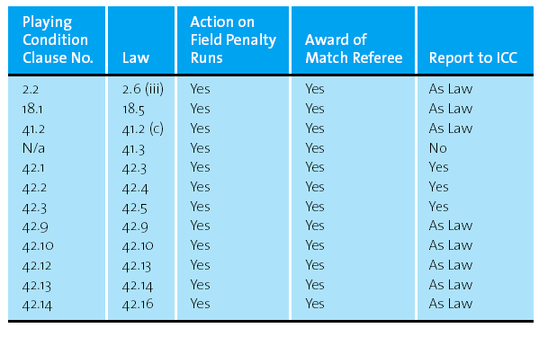

APPENDIX B

Calculation Sheet for Use When Delays or Interruptions Occur in First Innings of One Day Internationals

Time
Net playing time available at start of the match 420 minutes (A)
Time innings in progress __________ (B)
Playing time lost __________ (C)
Extra time available __________ (D)
Time made up from reduced interval __________ (E)
Effective playing time lost [C – (D + E)] __________ (F)
Remaining playing time available (A − F) __________ (G)

Overs and Fielding Restrictions
Overs in match [G / 4.2] round up fraction and +1 if necessary __________ (H)
Max. overs per team [H / 2] __________ (I)
Max. overs per bowler [I / 5] __________ overs
Fielding restrictions [I x 0.3] __________ overs
Fielding restrictions innings 1 __________ overs
Fielding restrictions innings 2 __________ overs [Note carefully Clause 41.2.7 is applied]
Rescheduled Playing Hours
First session to commence or recommence __________ (J)
Length of innings [I x 4.2] __________ (K)
Rescheduled cessation time [(J + K) – B] __________
Length of interval __________
Second session commencement time __________ (L)
Rescheduled cessation time = (L + K) __________
APPENDIX C

Calculation Sheet for Use When Delays or Interruptions Occur in Second Innings of One Day Internationals

Time
Original cessation time of innings (A)
Time at start of interruption (B)
Restart time (C)
Length of interruption [C – B] (D)
Extra time available (E)
Total playing time lost [D – E] (F)
Amended cessation time of innings [A + E] (G)

Overs
Maximum overs at start of innings (H)
Overs lost [F / 4.2] ignore fractions (I)
Adjusted maximum length of innings [H – I] (J)

Overs per bowler and Fielding Restrictions
Max. overs per bowler [J / 5] __________ overs
Fielding restrictions [J x 0.3] __________ overs

APPENDIX D
CREASE MARKINGS
17 inches (43.18 cm)
17 inches (43.18 cm)

APPENDIX 1

Restriction of the placement of fieldsmen

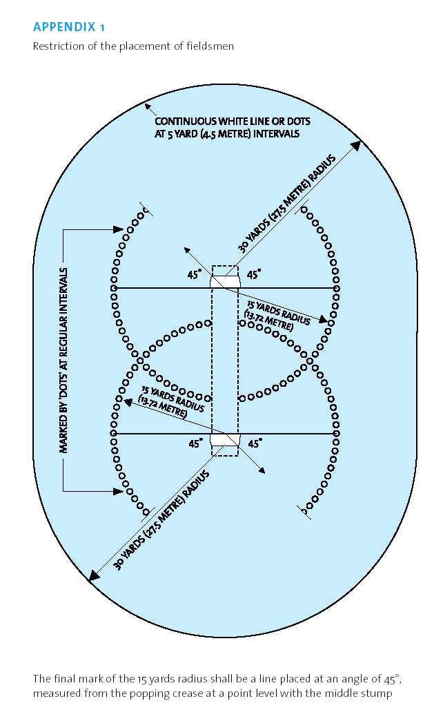

APPENDIX 2

Duckworth/Lewis Method of Re-calculating the Target Score in an Interrupted Match.

The Professional Edition of the Duckworth/Lewis shall be used in all matches. If any match is suspended after it has started such that the number of overs available to be faced by either side is reduced from that determined when the match started, the revised target shall be computed using the computer software CODA 70 (or later releases) in accordance with the instructions provided with that software and displayed on the screen.

Where possible, arrangements shall be made for the provision of back-up capability, in case of computer malfunction, for the operation or continued operation of the Professional Edition. In the event of computer malfunction at any time during the match where no such provision has been made, the Standard Edition (the method in use prior to October 2003) shall be used.

In the regulations given below, the tables given (including the ball-by-ball ones) and used in the illustrative examples, relate to the Standard Edition. These tables should be substituted by those appropriate to the particular match, which can be produced as directed within the software for the Professional Edition.

- Introduction

The D/L method sets revised targets in rain-interrupted limited-overs matches in accordance with the relative run scoring resources which are at the disposal of the two sides.

These are not in direct proportion to the number of overs available to be faced, as with the average run rate method of correction. Instead they depend on how many overs are to go and how many wickets are down when the interruptions occur.

To calculate the revised targets, you need to know the resources available at the stage of the match when suspensions and resumption of play occur. All possible values of resources have been pre-calculated and these are listed in the accompanying table.

The table covers each individual ball in a game of up to 50-overs per side. The figures given in the table are percentages of the resources available for a complete 50-over innings.

For matches with less than 50-overs per innings before they start, the resource percentages available at the start of an innings will be less than 100%. But the same table and the same method of calculation are used whatever the number of overs per innings.

The single sheet over-by-over version of the table can be used for cases when play is suspended before the start of a new over.

When Team 2 (the side batting second) have less run scoring resources at their disposal than had Team 1 (the side batting first), their target is adjusted downwards using the ratio of the resources available to the two sides.

But when Team 1’s innings has been interrupted, it often happens than Team 2 have more resources at their disposal than had Team 1 and it is now necessary to adjust Team 2’s target upwards.

In the Professional Edition the target is adjusted upwards using the ratio of the resources available to the two sides.

In the Standard Edition the adjustment is based on the runs that would be expected to be scored on average from the extra resources at their disposal. The number of these extra runs required is calculated by applying the excess resource percentage to the average total score in a 50-over innings, referred to here as G50

For matches involving ICC full member nations, including Under-19 international matches, or for matches between teams that play first class cricket, the value of G50 to be used at present is 235. For lower levels of the game, G50

should be chosen to represent the average score expected from the team batting first in an uninterrupted 50 overs-per-innings match. For teams between associate ICC member nations, the recommended value of G50 is 190; for women’s ODIs, the recommended value is 175. For U15 internationals, the recommended value is 200. For other levels of the game, advice should be sought from the ICC.

- Definitions

- The team batting first are referred to as ‘Team 1’ and the team batting second are referred to as ‘Team 2’.
- In the table decimal fractions of an over are expressed in standard cricket notation; i.e. 4.3 overs means 4 overs plus 3 balls.
- The terms ‘target’ and ‘revised target’ are reserved exclusively for the minimum score Team 2 need to win.
- As with an uninterrupted match, if Team 2 make a score which is one run short of the target, the match is tied.
The following symbols are used throughout:

N is the number of overs per innings for the match as decided at the moment of delivery of the first ball of the match.
S is Team 1’s total score
R1 is the resource percentage (relative to a full 50-over innings) available to Team 1.
R2 is the resource percentage (relative to a full 50-over innings) available to Team 2.
T is Team 2’s target score.

- Calculation of the Percentage Resource Lost by a Suspension in Play

To compensate for any loss of overs due to a suspension in play during either Team 1’s or Team 2’s innings, it is necessary first to calculate the resource percentage that has been lost on account of this suspension.

If the suspension occurs between overs, use the sheet of table which gives the figures for whole number of overs. If it occurs mid-over, use the sheet of table which provide the figures for each individual ball.

  - the start of the suspension in play, from the table note the resource percentage that remained for the appropriate number of overs/balls left and wickets lost.

  - For the resumption of play after the suspension, from the table note the resource percentage now remaining for the revised number of overs/balls left for the same number of wickets lost.

  - Subtract the resource percentage in 3.2 from that in 3.1 to give the resource percentage lost.

  - If a suspension in play causes the innings to be terminated, the resource percentage on resumption (3.2) is zero and the percentage lost is the resource percentage which was remaining when the suspension occurred (3.1)

  - If more than one suspension in play occurs, the resource percentage lost are calculated as described in 3.1 to 3.4 and are accumulated to give updated values for the total resource percentage lost or resource available for the innings. This is done after each suspension as described in 5.2 and 5.5.

- Penalties for Slow Over Rate

No overs penalties are imposed for slow over rates and hence slow over rates have no effect on the revised target calculations.

- Calculation of Revised Targets

  - Note the number of overs per innings decided at the start of the game, N. From the table note the resource percentage available to Team 1 at the start of the innings. (for N = 50 this is 100%)

  - For all suspensions and any premature termination of Team 1’s innings, calculate the total resource percentage lost using the procedure described in section 3. Subtract this from the starting resource percentage (5.1) to give R1, the resource which was available to Team 1 for their innings. Note Team 1’s total score, S.

  - There is no overs penalty for slow over rates by either side.

  - Note the number of overs allocated to Team 2 at the start of their innings and from the table note the resource percentage for this number of overs remaining and 0 wickets lost. This is R2, the resource percentage available to team 2. If R2 differs from R1, which will happen if team 1’s innings was interrupted and/or Team 2’s was delayed, a revised target must be set. Calculate this revised target, T, as described in 5.6 below.

  - For each suspension of play during Team 2’s innings or premature termination of the match, update the resource percentage available, R2, by subtracting the resource percentage lost calculated in section 3. Calculate the revised Target, T, after each suspension as described in 5.6 below. If the match has been terminated, the result is decided by comparing Team 2’s score at the time with the ‘Par Score’, this being the value as calculated in the formulae for T in 5.6 below but without the one run added. If it is greater, then Team 2 win. If it is equal, the match is tied. If it is less, then team 1 win.

  - In the professional Edition, for all values of R1 and R2 the revised target is obtained by scaling Team 1’s score ratio of R2 to R1

i.e. T = (S x R2/R1) + 1 (rounded down to a whole number, if necessary.

In the Standard Edition, if R2 is less than R1, team 2’s revised target is obtained by reducing Team 1’s score S in the ratio of R2 to R1, ignoring any figures after the decimal point, and adding one run,
i.e. T – (S x R2/R1) + 1 (rounded down to a whole number, if necessary)

If R2 is equal to R1, no revision is needed and team 2’s target is one more run than Team’s 1 score.

i.e. T = S + 1

If R2 is greater than R1, calculate the amount of excess R2 – R1, and take this percentage of
the average 50 over total, G50, to give the extra runs needed, ignoring any figures after the
decimal point.

i.e. T = S + (R2 – R1) x G50/100 +1 (rounded down to a whole number, if necessary)

- Penalty Runs

6.1 During Team 1’s innings

If penalty runs are awarded to the batting side, then their score shall advance accordingly and be taken into account
when performing any future D/L calculation.

If penalty runs are awarded to the fielding side, then any D/L calculation in between innings will be performed as
normal, and their innings will commence with the score equivalent to the number of penalty runs that they have
been awarded.

6.2 During Team 2’s innings

If penalty runs are awarded to the batting side, then their score shall advance accordingly. These penalty runs
do not affect any subsequent D/L calculation.

If penalty runs are awarded to the fielding side , then there will be no recalculation of any D/L target. Instead, the
target score and the entire schedule of par score will advance by the appropriate number of penalty runs. If a loss
of overs occurs after such penalty has been awarded, then the D/L target will be calculated based upon the original
score of the side batting first , and this target, and all par scores, will then be raised by the appropriate number of
of penalty runs.

- The Result and its Description

When a revised target has been calculated and the match has been played out to its completion, the result is described exactly as in the case of an uninterrupted match; if Team 2 achieves their revised target they win by the number of wickets they have in hand when they reach this score; if they fall short of their revised target by exactly one run the result is a tie, and if they make a lower score Team 1 win by the margin of runs by which Team 2 falls short of the score needed to achieve a tie.

When a match has to be abandoned with Team 2’s innings in progress(provided sufficient overs have been bowled to constitute a viable match), the result is decided by comparing Team 2’s score with the ‘par score’ as defined in 5.5 and the winning margin is described in terms of the number of runs by which their score differs from ‘par score’, regardless of whether Team 1 or team 2 are the victors.

Whenever a completed game has involved the use of D/L method, the description should be qualified by appending ‘(D/L method)’.

  - Examples of result description :

- Team2 are set a revised target of 186. But they only succeed in making 180 in their allocation of overs. They thus fall 5 runs short of the 185 runs to tie the match and the result is described as ‘Team 1 win by 5 runs(D/L method)’.

- Team 2 are chasing a target of 201 in 50-overs per innings match and reach 115/4 after 30 overs, when rain causes the match to be abandoned. At this point the ‘par score’ is 110. Team 2 have exceeded this by 5 runs and so the result is described as ‘Team 2 win by 5 runs(D/L method)’.

Example 1 (Suspension during Team 1’s innings)

In a 50 over-per-innings match, Team 1 reaches 79/3 after 20 overs and then there is a suspension in play. It is decided that 20 overs of the match should be lost, 10 of these by each team. Team 1 resumes to reach a final total of 180 in its revised allocation of 40 overs.

Number of overs per innings at the start of the match, N = 50 overs
Resource percentage available to Team 1 at start of innings = 100% (5.1)
Resource percentage remaining at suspension (30 overs left, 3 wkts lost = 61.6% (3.1)
Resource percentage remaining at resumption (20 overs left, 3 wkts lost = 49.1% (3.2)
Resource percentage lost due to suspension = 61.6 – 49.1 = 12.5% (3.3)
Resource percentage available to Team 1 , R1 = 100 – 12.5 = 87.5% (5.2)
Number of overs available to Team 2 at the start of its innings = 40
Resource percentage available to Team 2 (40 overs left 0 wkts lost), R2 = 89.3% (5.4)
R2 is greater than R1. i.e. Team 2 has more resource available that had Team 1, so its target should be increased.
S =180
Hence Team 2’s revised target (5.6) is

T = S + G50 x (R2-R1) / 100 + 1 = 180 + 235 x (89.3 – 87.5) / 100 + 1 = 185 (rounded down)

Example 2 (delay to start of Team 2’s innings)

In an English National League match (45 overs per innings), Team 1 scores 212 in its allocated 45 overs. Rain then causes Team 2’s response to be delayed and it is decided that it should be shortened to 35 overs.

Number of overs at start of the match, N = 45
Resource percentage available to Team 1 at start of its innings (45 overs left, o wkts lost) = 95.0% (5.1)
The innings was not interrupted, so R1 = 95.0%
Number of overs available to Team 2 at start of its innings = 35
Resource percentage available to Team 2 at start of its innings (35 overs left, o wkts lost) , R2 = 82.7% (5.4)
R2 is less than R1; S = 212
Team 2’s revised target (5.6) is T = s x R2/R1 = 212 x 82.7 / 95.0 + 1 = 185 (Rounded down)

Example 3 (suspension during team 2’s innings)

In an One day International match (50 overs per innings), Team 1 has scored 250 from its allocation of 50 overs in an uninterrupted innings. Team 2 has received 12 overs and has scored 40/1. Then play is suspended and 10 overs are lost.

Number of overs at start of the match, N = 50.
Team 1’s innings was uninterrupted, so its resource percentage available, R1 = 100% (5.1)
Resource percentage available to team 2 at start of innings = 100% (5.4).
Resource percentage remaining at suspension (38 overs left, 1 wkt lost) = 82.0% (3.1)
Resource percentage remaining at resumption (28 overs left, 1 wkt lost) = 68.8% (3.2)
Resource percentage lost due to suspension 82.0 – 68.8 = 13.2% (3.3)
Resource percentage available to Team 2 , R2 = 100 – 13.2 – 86.8% (5.5)
R2 is less that R1; S = 250

Team 2’s revised target (5.6) is T = s x R2 / R1 + 1 = 250 x 86.8 / 100 +1 = 218, and it needs a further 178 runs from 28 overs.

Example 4 (multiple suspensions and abandonment)

Suppose that in Example 3, play continues a further 10 overs during which Team 2 takes its score on to 89/3, whereupon there is another suspension in play and 2 more overs are lost. A further 8.2 overs are bowled and Team 2 is 154/6 when rain washes out the match.

Team 1’s resource percentage is still R1 = 100%

Team 2’s resource percentage has been reduced further.

Resource percentage remaining at start of second suspension (18 overs left, 3 wkts lost) = 45.9% (3.1)
Resource percentage remaining at the end of second suspension (16 overs left, 3 wkts lost) = 42.3% (3.2)
Resource percentage lost due to second suspension = 45.9 – 42.3 = 3.6% (3.3)
Resource percentage available to Team 2, R2 = 86.8 – 3.6 = 83.2% (5.5)

R2 is less than R1; S = 250

Team 2’s revised target (5.6) is T = S x R2 / R1 + 1 = 250 x 83.2 / 100 + 1 = 209 and it needs a further 111 runs from 16 overs.
When the innings had to be terminated there were 7.4 overs remaining.

Resource percentage remaining at termination of Team 2’s innings (7.4 overs left, 6 wkts lost) = 19.4%
This remaining resource is lost by the termination.

Resource percentage available to Team 2 , R2 = 83.2 – 19.4 = 63.8% (5.5)
R2 is less than R1; S = 250

At the instant of abandonment Team 2’s ‘par score’ (5.5 and 5.6) is S x R2/R1 + 250 x 63.8/100 = 159 (rounded down), and with a score of 154 it has lost by 5 runs. Team 1 wins by 5 runs (D/L method) (7).

Example 5 (suspension and termination of Team 1’s innings mid over and delay to Team 2’s innings)

This is taken from an actual ODI: India (team 1) versus Pakistan (Team 2), Singapore, April 1996. Team 1 scores 226/8 in 47.1 overs of scheduled 50 overs. Rain then terminates Team 1’s innings and delays that of Team 2, which is given a reduced allocation of 33 overs.

Number of overs per innings at start of match, N = 50

Team 1’s innings:

Resource percentage at start of innings is 100% (5.1)
Resource percentage remaining at termination (2.5 overs, 8 wkts lost) =6.9% (3.1)
Resource percentage lost due to termination = 6.9% (3.4)
Resource percentage available, R1 = 100 – 6.9 = 93.1% (5.3)

Team 2’s innings (allocated 33 overs):

Resource percentage at start of innings (33 overs left, 0 wkts lost) R2 = 79.8% (5.4)
R2 is less than R1; S = 226

Team 2’s revised target (5.6) is T = S x R2 / R1 +1 = 226 x 79.8 / 93.1 + 1 = 194 (rounded down).

Example 6 (as Example 5 but with further interruption during Team 2’s innings)

In the match of the previous example, Team 2 has scored 140 for 2 after 25 overs when a further 5 overs are lost to the weather.

Team 1’s resource percentage is still R1 = 93.1%

Team 2’s innings:

Resource percentage at start of innings (33 overs left, 0 wkts lost) = 79.8% (5.4)
Resource percentage remaining at suspension (8 overs left, 2 wkts lost) = 25.5% (3.1)
Resource percentage remaining at resumption (3 overs left, 2 wkts lost) = 10.4% (3.2)
Resource percentage lost due to suspension = 25.5 – 10.4 = 15.1% (3.3)
Resource percentage available, R2 = 79.8 – 15.1 = 64.7% (5.2)

R2 is less than R1 ; S = 226.

Team 2’s revised target (5.6) is T = S x R2 / R1 + 1 = 226 x 64.7 / 93.1 + 1 = 158 and it need a further 18 runs from 3 overs.

Note : These calculations and the use of the Standard Edition of The D/L (Duckworth/Lewis) method of adjusting target scores in interrupted one-day cricket matches is to be used only when Professional Edition is not available.

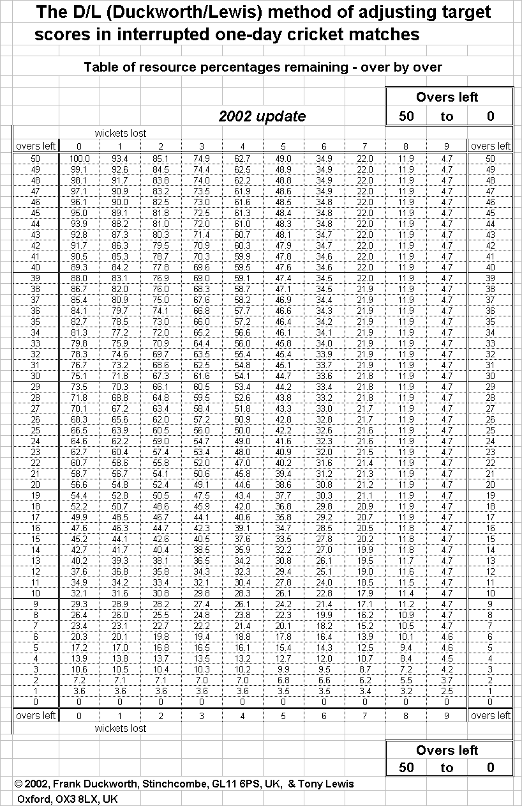
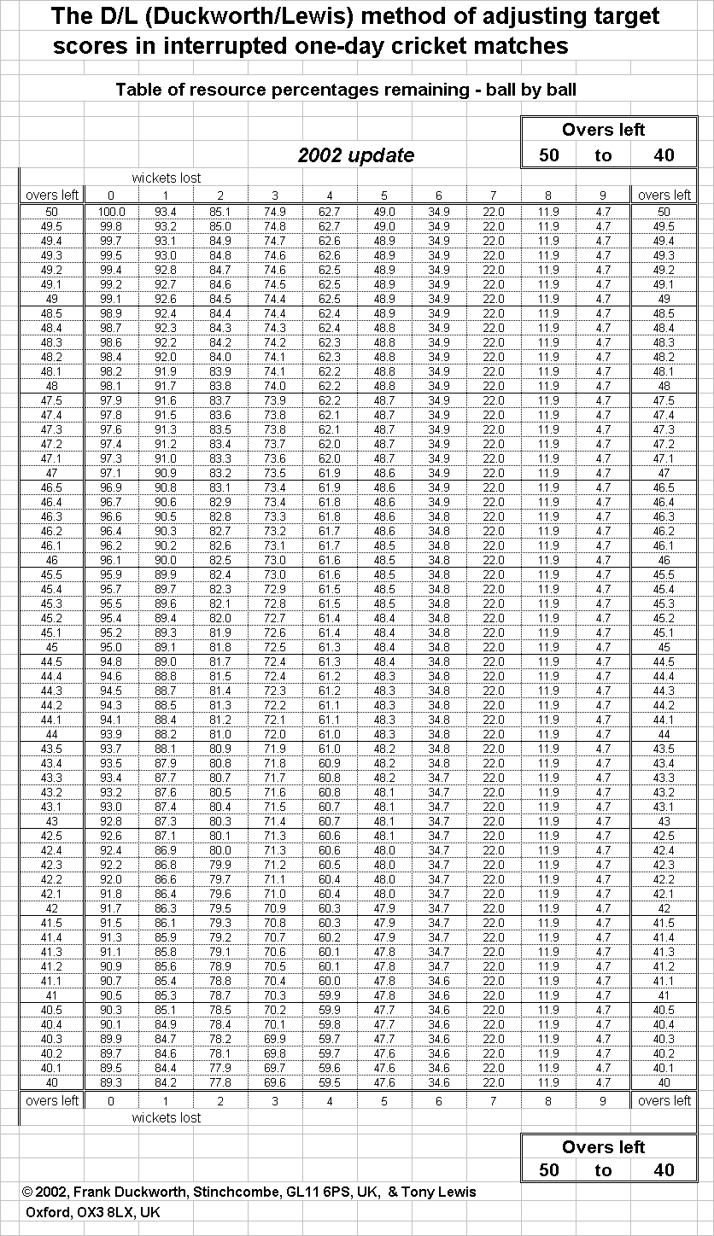
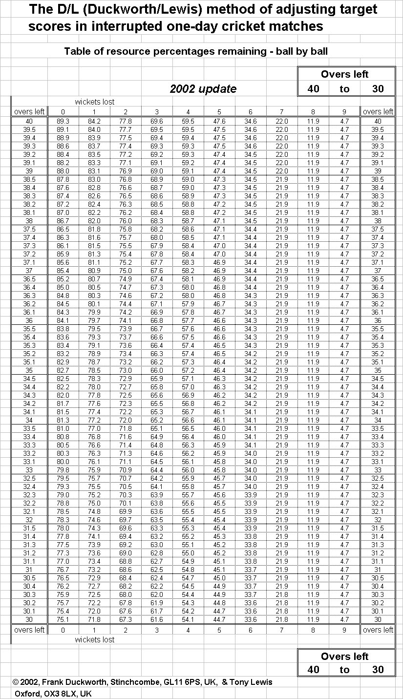
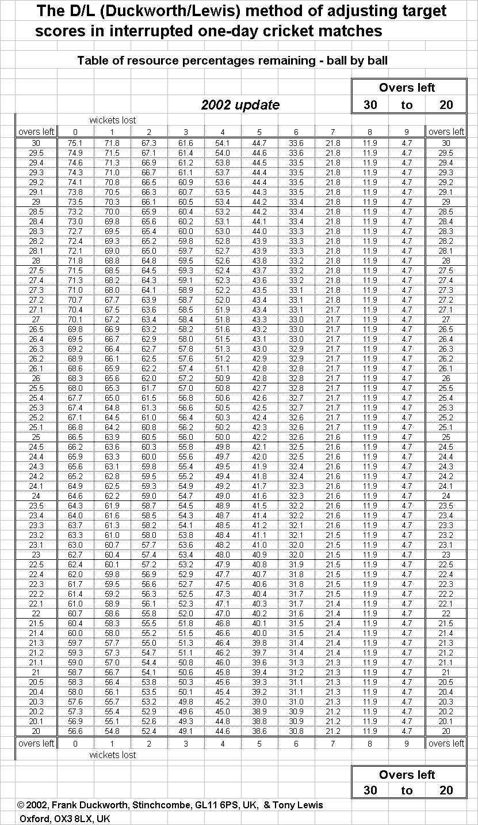
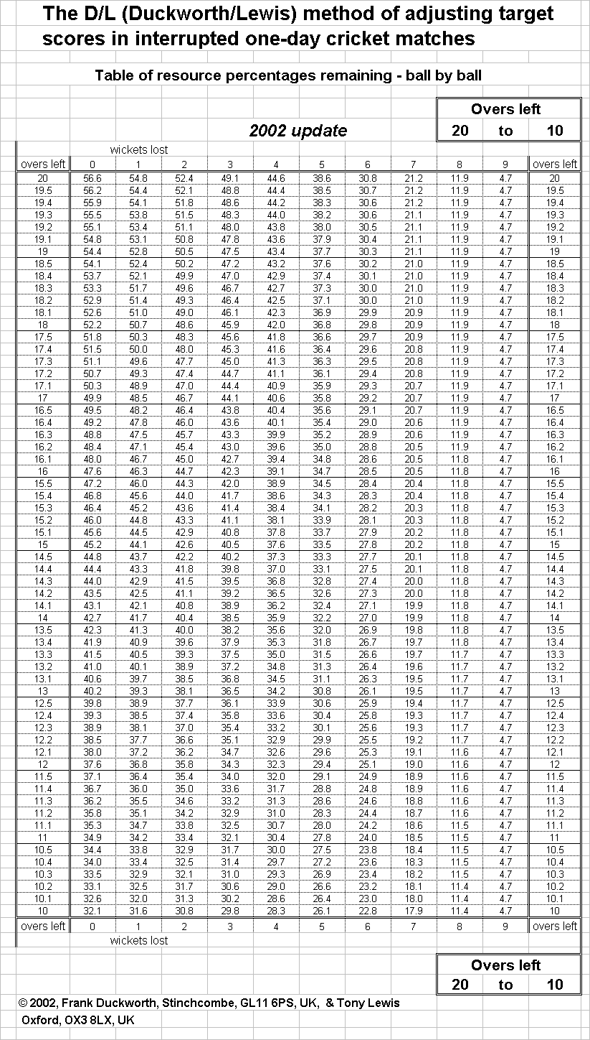
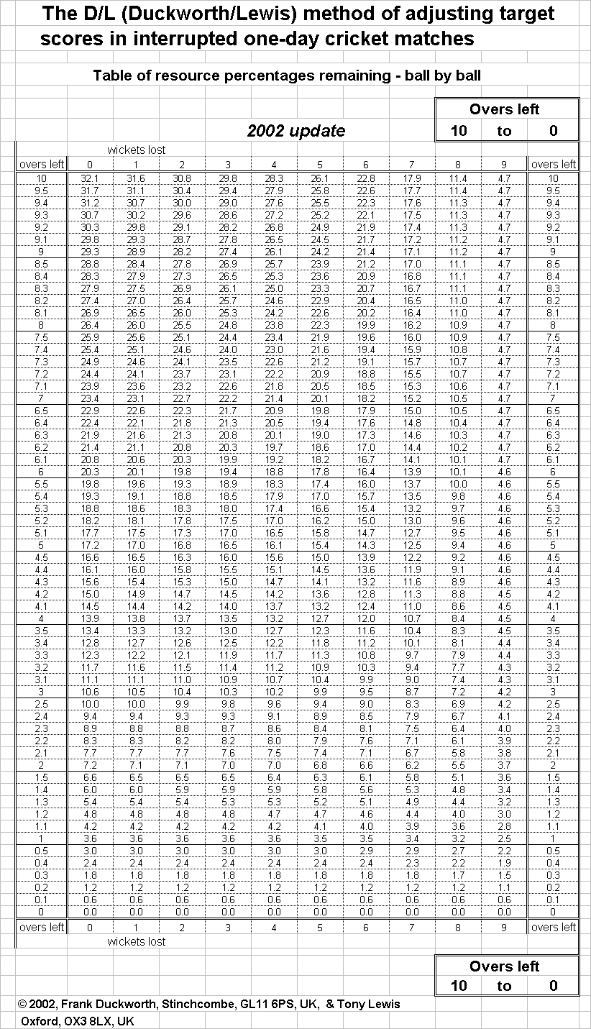

APPENDIX 3

Numerical examples of adjustment to POWERPLAY Overs following an interruption

A 50 over innings is interrupted after 9.3 overs, and on resumption has been reduced to
(a) 40 overs, (b) 30 overs, (c ) 20 overs

(a) Powerplay Overs are 8+4+4. 2nd Powerplay is in progress with 1.3 out of 4 overs
completed. The fielding captain may choose to have three outfielders either for the next 2.3
overs or for the 4 overs of the 3rd Powerplay.
(b) Powerplay overs are 6+3+3. 3rd Powerplay is in progress with 0.3 out of 3 overs are
completed. Three outfielders are permitted for the next 2.3 overs.
(c ) Powerplay overs are 4+2+2. All Powerplay overs have been completed. Non-Powerplay
restrictions take effect immediately and do not need to wait until the end of the over.

A 50 over innings in which only the 1st Powerplay has been taken is interrupted after 34.2 overs and reduced to 40 overs. Powerplay overs are 8+4+4. Powerplays resume for the next over (36th). Since the number of Powerplay overs required(16) exceed the number possible (15) by 1, only 3 of the remaining Powerplay overs may be bowled with three outfielders.

